What is Java?

Java is a **programming language** and a **platform**. Java is a high-level, robust, object-oriented and secure programming language.

Java was developed by *Sun Microsystems* (which is now a subsidiary of Oracle) in the year 1995. *James Gosling* is known as the father of Java. Before Java, its name was *Oak*. Since Oak was already a registered company, so James Gosling and his team changed the name from Oak to Java.

**Platform:** Any hardware or software environment in which a program runs is known as a platform. Since Java has a runtime environment (JRE) and API, it is called a platform.

Application

According to Sun Microsystems, 3 billion devices run Java. There are various devices where Java is currently used. Some of them are as follows:

1. Desktop Applications such as Acrobat Reader, media player, antivirus, etc.
2. Web Applications such as irctc.co.in, tpointtech.com, etc.
3. Enterprise Applications such as banking applications.
4. Mobile
5. Embedded System
6. Smart Card
7. Robotics
8. Games, etc.

Types of Java Applications

There are the following 4-types of applications that can be created using Java programming:

1) Standalone Application

Standalone applications are also known as desktop applications or window-based applications. These are traditional software that we need to install on every machine. Examples of standalone applications are Media players, antivirus, etc. AWT and Swing are used in Java for creating standalone applications.

2) Web Application

An application that runs on the server side and creates a dynamic page is called a web application. Currently, [Servlet](https://www.tpointtech.com/servlet-tutorial), [JSP](https://www.tpointtech.com/jsp-tutorial), [Struts](https://www.tpointtech.com/struts-2-tutorial), [Spring](https://www.tpointtech.com/spring-tutorial), [Hibernate](https://www.tpointtech.com/hibernate-tutorial), [JSF](https://www.tpointtech.com/jsf-tutorial), etc. technologies are used for creating web applications in Java.

3) Enterprise Application

An application that is distributed in nature, such as banking applications, etc. is called an enterprise application. It has advantages like high-level security, load balancing, and clustering. In Java, [EJB](https://www.tpointtech.com/ejb-tutorial) is used for creating enterprise applications.

4) Mobile Application

An application that is created for mobile devices is called a mobile application. Currently, Android and Java ME are used for creating mobile applications.

Java Platforms / Editions

There are four platforms or editions of Java:

1) Java SE (Java Standard Edition)

It is a Java programming platform. It includes Java programming APIs such as java.lang, java.io, java.net, java.util, java.sql, java.math etc. It includes core topics like OOPs, [String](https://www.tpointtech.com/java-string), Regex, Exception, Inner classes, Multithreading, I/O Stream, Networking, AWT, Swing, Reflection, Collection, etc.

2) Java EE (Java Enterprise Edition)

It is an enterprise platform that is mainly used to develop web and enterprise applications. It is built on top of the Java SE platform. It includes topics like Servlet, JSP, Web Services, EJB, [JPA](https://www.tpointtech.com/jpa-tutorial), etc.

3) Java ME (Java Micro Edition)

It is a micro platform that is dedicated to mobile applications.

4) JavaFX

It is used to develop rich Internet applications. It uses a lightweight user interface API.

Features of Java

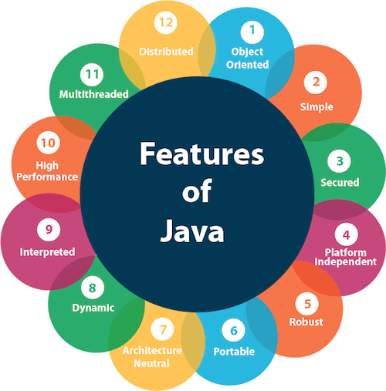

Interpreted

Java's interpreted feature means that Java code is not directly converted into machine code by a compiler. Instead, first, it compiled into **bytecode**, then executed by the **JVM**through an **interpreter**. It allows Java to be **platform-independent**, meaning the same bytecode can run on any system with a JVM.

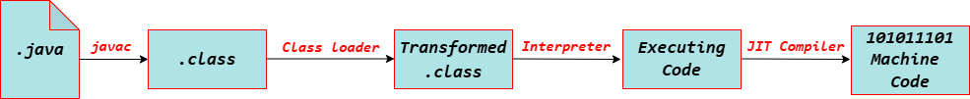

However, modern JVMs use **Just-In-Time (JIT) compilation**, which converts bytecode into native machine code at runtime, improving performance while retaining Java's interpreted behavior.

Difference between JDK, JRE, and JVM

JVM

JVM (Java Virtual Machine) is an abstract machine. It is called a virtual machine because it doesn't physically exist. It is a specification that provides a runtime environment in which [Java](https://www.tpointtech.com/java-tutorial) bytecode can be executed. It can also run those programs that are written in other languages and compiled to Java bytecode.

JVMs are available for many hardware and software platforms. JVM, JRE, and JDK are platform dependent because the configuration of each [OS](https://www.tpointtech.com/os-tutorial) is different from that of others. However, Java is platform independent. There are three notions of the JVM: *specification*, *implementation*, and *instance*.

The JVM performs the following main tasks:

* Loads code
* Verifies code
* Executes code
* Provides runtime environment

JRE

[JRE](https://www.tpointtech.com/java-jre) is an acronym for Java Runtime Environment. It is also written as Java RTE. The Java Runtime Environment is a set of software tools that are used for developing Java applications. It is used to provide the runtime environment. It is the implementation of JVM. It physically exists. It contains a set of libraries + other files that the JVM uses at runtime.

The implementation of JVM is also actively released by other companies besides Sun Microsystems.

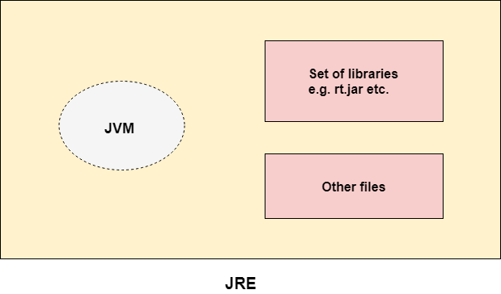

JDK

JDK is an acronym for Java Development Kit. The Java Development Kit (JDK) is a software development environment that is used to develop Java applications and [applets](https://www.tpointtech.com/java-applet). It physically exists. It contains JRE + development tools.

JDK is an implementation of any one of the below given Java Platforms released by Oracle Corporation:

* Standard Edition Java Platform
* Enterprise Edition Java Platform
* Micro Edition Java Platform

The JDK contains a private Java Virtual Machine (JVM) and a few other resources, such as an interpreter/loader (java), a compiler (javac), an archiver (jar), a documentation generator (Javadoc), etc., to complete the development of a Java Application.

